Internationalization of RESTful Services

In this section, we will discuss the Internationalization of the RESTful Web Services.

Internationalization

Internationalization is the process of designing web applications or services in such a way that it can provide support for various countries, various languages automatically without making the changes in the application. It is also known as **I18N** because the word internationalization has total 18 characters starting from **I** to **N**.

Localization is performed by adding locale-specific components such as translated text, data describing locale-specific behavior, etc. It supports full integration into the classes and packages that provide language-or-culture-dependent functionality.

Java provides the foundation for internationalization for desktop and server applications. There are following important internationalized areas of functionality.

* **Text Representation:** Java is based on the Unicode character set, and several libraries implement the Unicode standard.
* **Locale identification and localization:** Locale in Java are identifiers that can be used to request locale-specific behavior in different areas of functionality. Localization is supported by ResourceBundle class. The class provides access to local specific objects, including strings.
* **Date and time handling:** Java provides various calendars. It supports conversion to and from calendar independent Date objects. Java supports all the time zones in the world.
* **Text processing:** It includes character analysis, case mapping, string comparison, breaking text into words, formatting numbers, dates, and time values into strings or parsing them back from strings. Most of these functions are locale-dependent.
* **Character encoding:** It supports converting text between Unicode and other character encodings when reading incoming text from the streams or writing outgoing text to the streams.

We need to configure two things to make the service internationalized.

* LocaleResolver
* ResourceBundleMessageSource

Default Locale is Locale.US. If somebody does not specify the location, it returns the default locale. We also need to customize the ResourceBundle. It has a list of properties that are to be internationalized. We will store the properties in ResourceBundle. **ResourceBundleMessageSource** is a Spring MVC concept for handling properties. After that, we will use MessageSource, and a header called Accept-Language.

Let's configure the internationalization.

**Step 1:** Open **RestfulWebServicesApplication.java** file.

**Step 2:** Configure a Bean for **default** locale.

1. @Bean
2. **public**  LocaleResolver localeResolver()
3. {
4. SessionLocaleResolver localeResolver = **new** SessionLocaleResolver();
5. localeResolver.setDefaultLocale(Locale.US);
6. **return** localeResolver;
7. }

*Note: Import import org.springframework.web.servlet.LocaleResolver package while importing LocaleResolver.*

**Step 3:** Now, we will store properties in a specific file called **messages.properties**.

Right-click on **src/main/resources** folder -> New -> File -> Provide the file name: **messages.properties**. It contains the default locale message.

**messages.properties**

1. good.morning.message=Good Morning

**Step 4:** Create another property file with the name **messages_fr.properties** for French locale. It contains a message for the French locale.

**messages_fr.properties**

1. good.morning.message=Bonjour

**Step 5:** Read properties and customize them based on the input accept header. Open the RestfulWebServicesApplication.java and configure another Bean for **ResourceBundle**.

1. //configuring ResourceBundle
2. @Bean
3. **public** ResourceBundleMessageSource bundleMessageSource()
4. {
5. ResourceBundleMessageSource messageSource = **new** ResourceBundleMessageSource();
6. messageSource.setBasename("messages");
7. **return** messageSource;
8. }

**RestfulWebServicesApplication.java**

1. **package** com.javatpoint.server.main;
2. **import** java.util.Locale;
3. **import** org.springframework.boot.SpringApplication;
4. **import** org.springframework.boot.autoconfigure.SpringBootApplication;
5. **import** org.springframework.context.annotation.Bean;
6. **import** org.springframework.context.support.ResourceBundleMessageSource;
7. **import** org.springframework.web.servlet.LocaleResolver;
8. **import** org.springframework.web.servlet.i18n.SessionLocaleResolver;
9. @SpringBootApplication
10. **public** **class** RestfulWebServicesApplication
11. {
12. **public** **static** **void** main(String[] args)
13. {
14. SpringApplication.run(RestfulWebServicesApplication.**class**, args);
15. }
16. //configuring default locale
17. @Bean
18. **public**  LocaleResolver localeResolver()
19. {
20. SessionLocaleResolver localeResolver = **new** SessionLocaleResolver();
21. localeResolver.setDefaultLocale(Locale.US);
22. **return** localeResolver;
23. }
24. //configuring ResourceBundle
25. @Bean
26. **public** ResourceBundleMessageSource messageSource()
27. {
28. ResourceBundleMessageSource messageSource = **new** ResourceBundleMessageSource();
29. messageSource.setBasename("messages");
30. **return** messageSource;
31. }
32. }

**Step 6:** Update the service to use these sources. Open the **HelloWorldController.java** and autowired the MessageSource.

1. @Autowired
2. **private** MessageSource messageSource;

**HelloWorldController.java**

1. **package** com.javatpoint.server.main.helloworld;
2. **import** org.springframework.web.bind.annotation.GetMapping;
3. **import** org.springframework.web.bind.annotation.PathVariable;
4. **import** org.springframework.web.bind.annotation.RequestHeader;
5. **import** org.springframework.web.bind.annotation.RestController;
6. **import** java.util.Locale;
7. **import** org.springframework.beans.factory.annotation.Autowired;
8. **import** org.springframework.context.MessageSource;
9. **import** org.springframework.context.annotation.Configuration;
10. @Configuration
11. //Controller
12. @RestController
13. **public** **class** HelloWorldController
14. {
15. @Autowired
16. **private** MessageSource messageSource;
17. //using get method and hello-world URI
18. @GetMapping(path="/hello-world")
19. **public** String helloWorld()
20. {
21. **return** "Hello World";
22. }
23. @GetMapping(path="/hello-world-bean")
24. //method- which returns "Hello World"
25. **public** HelloWorldBean helloWorldBean()
26. {
27. **return** **new** HelloWorldBean("Hello World");//constructor of HelloWorldBean
28. }
29. //passing a path variable
30. //hello-world/path-variable/javatpoint
31. @GetMapping(path="/hello-world/path-variable/{name}")
32. **public** HelloWorldBean helloWorldPathVariable(@PathVariable String name)
33. {
34. **return** **new** HelloWorldBean(String.format("Hello World, %s",name));   //%s replace the name
35. }
36. //internationalization
37. @GetMapping(path="/hello-world-internationalized")
38. **public** String helloWorldInternationalized(@RequestHeader(name="Accept-Language", required=**false**) Locale locale)
39. {
40. **return** messageSource.getMessage("good.morning.message", **null**, locale);
41. }
42. }

**Step 7:** Open the REST client **Postman** and perform the following changes:

* Select the **GET** request.
* Type the URI http://localhost:8080/hello-world-internationalized
* Click on **Headers** tab and type:

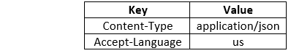

* Click on the Send button.

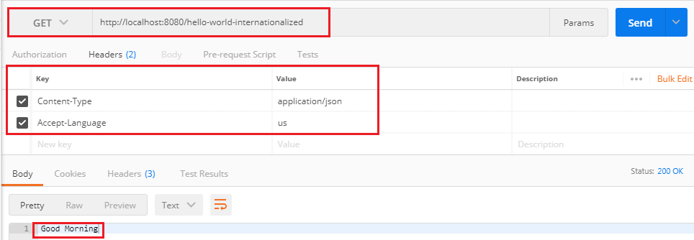

It returns the US locale message **Good Morning**.